Final Final PrintAhead 2.0 Fixes 12.12

Artem,

I don’t want to nitpick too much, but I will market PrintAhead 2.0 to a completely new audience, who are NOT familiar with 3D and will be scared by it. Therefore, it must be perfect before I start to release it.

Still small bugs:

1. Need to change the Help menu as shown (without the red numbers)

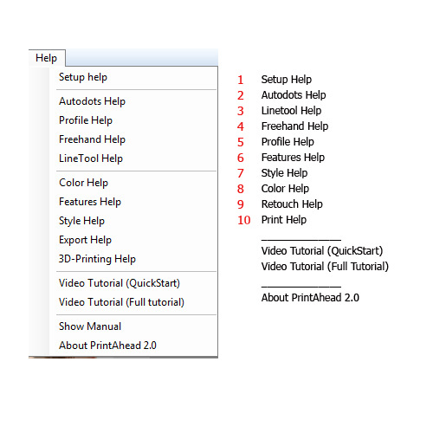

1. The Teach panels need to appear automatically when user clicks on the numbered buttons or tools

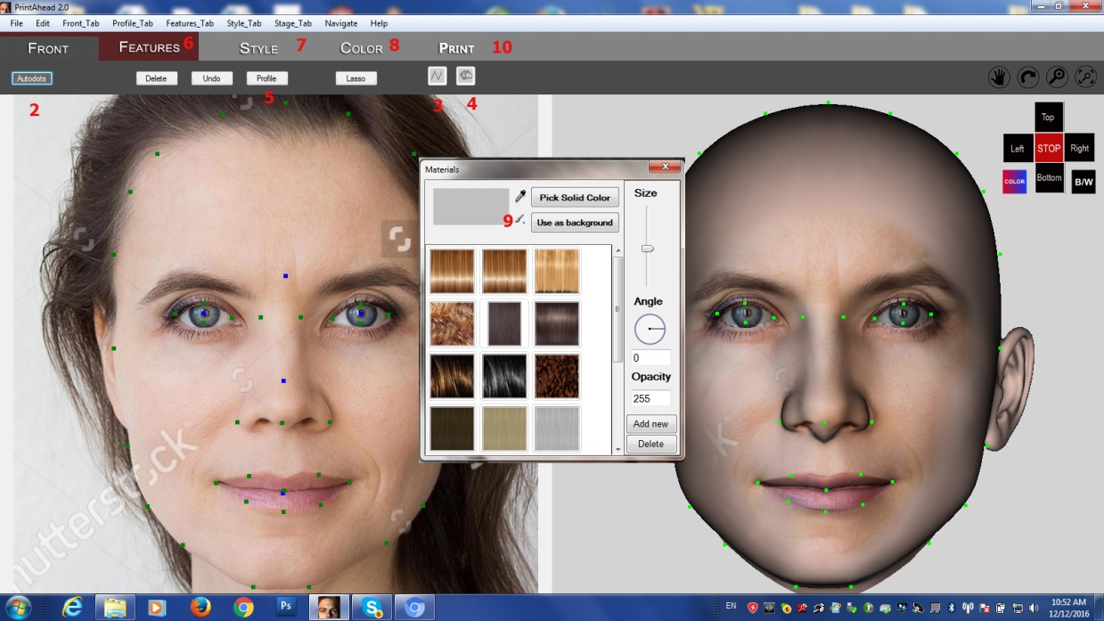

1. For some reason the Autodots teach panel appears twice after you click Apply on the setup screen.
2. After working through 100 different pictures, 98% of the time the tip of the nose dot is too low. It would be better if we moved the default a little higher as shown.

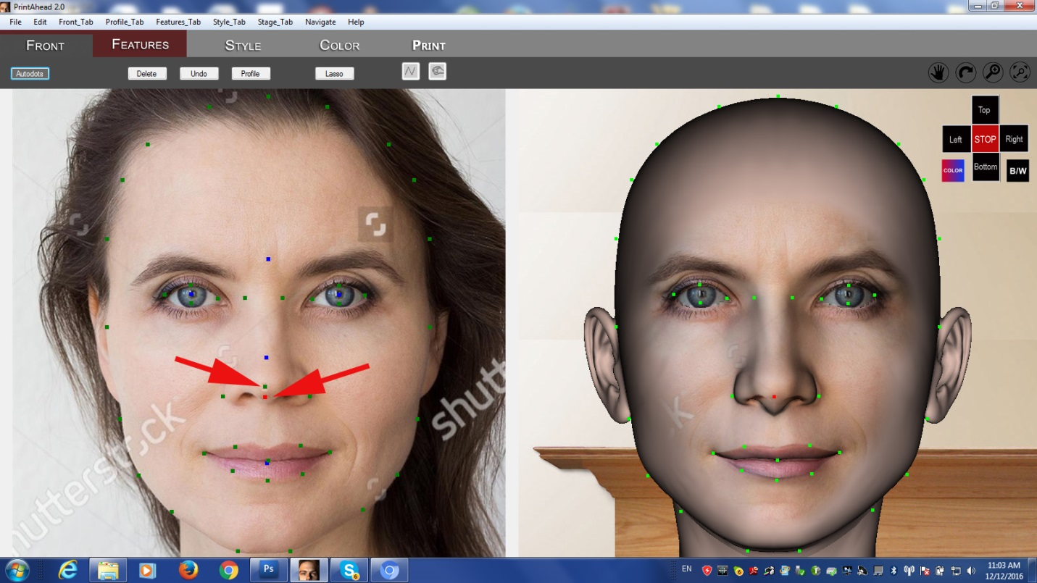

1. The area around Print Tab does not change color like the other tabs do

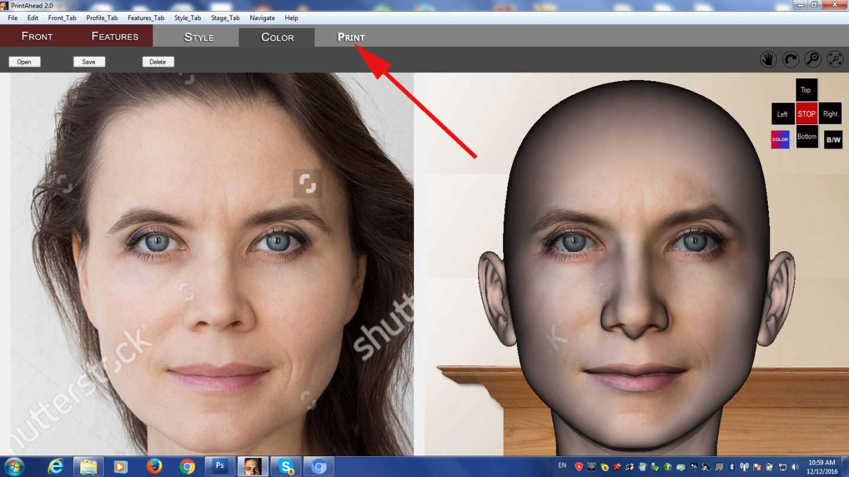

This really is all – sorry to keep bugging you, but this is a very important product for me.